CAEx and Iteca Exhibitions Transforming Uzbekistan's Exhibition Landscape

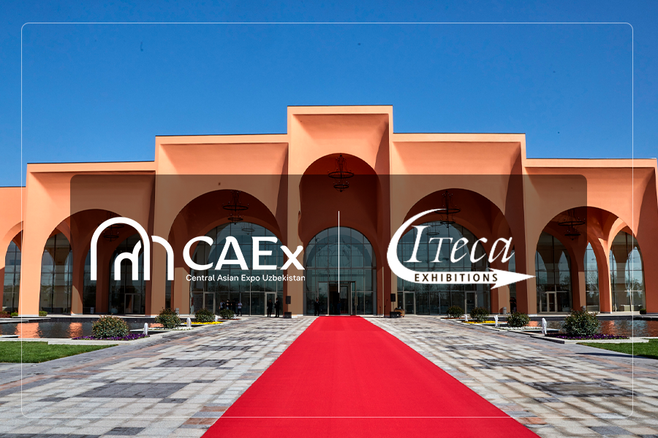

About CAEx Uzbekistan
CAEx Uzbekistan is a modern exhibition venue with a total area of 23,000 square meters, is one of the largest exhibition venues in Central Asia. Due to its potential, CAEx has already become a member of the Global Association of the Exhibition Industry (UFI) and the International Association of Exhibitions and Events (IAEE). The CAEx infrastructure allows it to be used as a multifunctional platform for hosting large local and international events, including congresses, national, and international exhibitions.
It is also worth highlighting the architectural design of the complex. This impressive exhibition structure combines elements of Eastern architecture with modern design.
The spacious pavilion of the exhibition complex can accommodate up to 30,000 people, making it an ideal venue for various events.
Notable Events
CAEx regularly hosts events of various scales. The venue has already featured Nobel Peace Prize laureate Muhammad Yunus, British entrepreneur and perfumer Jo Malone, Hollywood actor and stuntman Scott Adkins, Elon Musk's mother Maye Musk, actress Meryem Uzerli, entrepreneur and public figure Margulan Seisembayev, and others.
In just one year of operation, CAEx has successfully hosted industry exhibitions, and CAEx Mebel & Decor attracted more than 7,000 unique visitors.
Joint Plans of CAEx and Iteca Exhibitions
On 14 August 2024 Iteca Exhibitions announced four projects to be held at the CAEx venue.
The international exhibition company Iteca Exhibitions is a leading organiser of international exhibitions and conferences, as well as a member of the Chamber of Commerce and Industry of the Republic of Uzbekistan, the Global Association of the Exhibition Industry (UFI), the European-Uzbekistan Association for Economic Cooperation (EuroUz), and the American Chamber of Commerce in Uzbekistan (AmCham).
Since holding its first B2B exhibition in 1995, the company has pioneered the development of the exhibition industry in Uzbekistan. Over 29 years, Iteca Exhibitions has firmly established itself as the leading player in the international exhibition and conference market in the country. Today, the company's portfolio includes 20 international exhibitions and 4 conferences, annually attracting more than 4,000 exhibitors and 3,500 delegates from 57 countries, as well as over 105,000 visitors.
The emergence of the new, modern CAEx venue has opened up new opportunities for hosting major exhibitions. After lengthy negotiations, key agreements were reached, and Iteca Exhibitions is ready to announce plans to hold a number of exhibition projects at the new location in 2025, including:
- Uzbekistan Construction and Interior Week:
UzBuild — Construction, BuildTech — Building Equipment and Technologies;
- TIHE — Healthcare;
- Uzbekistan Energy Week:
OGU — Oil and Gas of Uzbekistan, Power Uzbekistan — Energy, Energy Saving, Alternative Energy Sources;
- CAITME — Textile Machinery and Technologies.

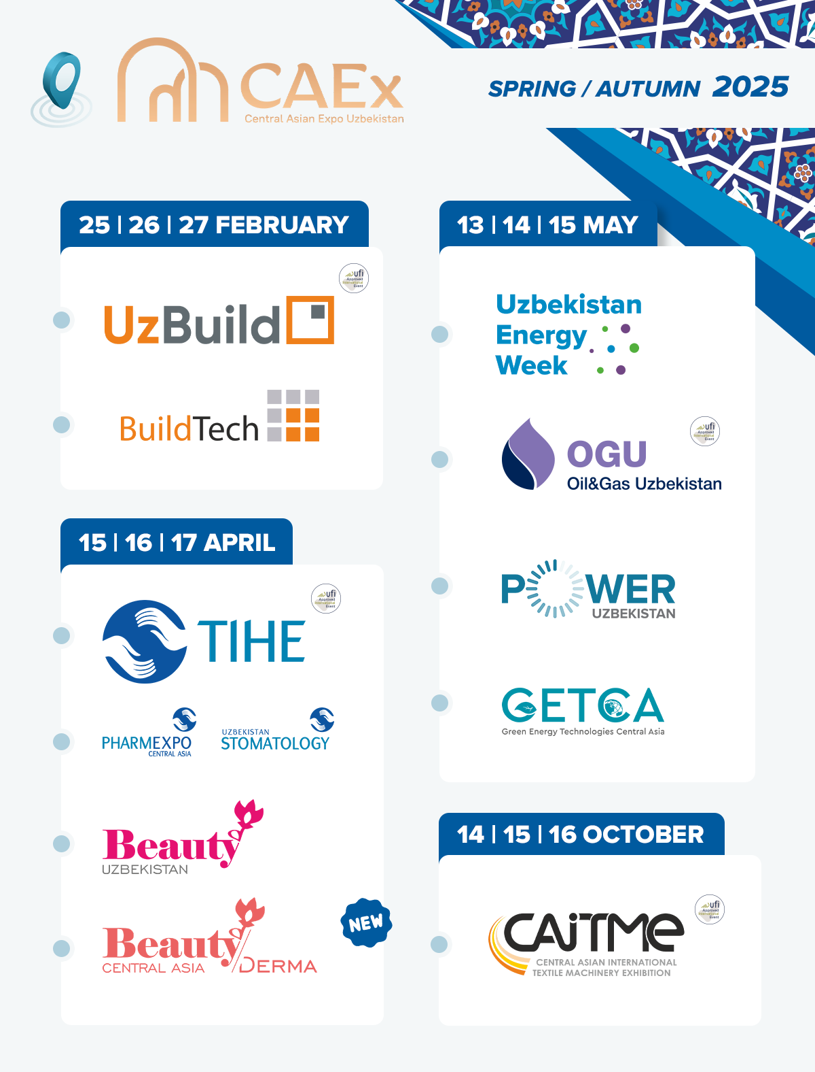

In 2025, the company plans a series of rebranding and the launch of new projects, including the updated Beauty Uzbekistan exhibition in the format of BeautyDerma Central Asia, which will be held simultaneously with TIHE, the main medical exhibition of Uzbekistan, in April 2025 at the CAEx venue.
The transition of the main player in the exhibition industry to the new CAEx venue promises to change the exhibition landscape of Uzbekistan, as well as give a further boost to the development of the capital's infrastructure.

